**Exercise**

1. Declare a structure named employee that stores the employee id, name, salary and

department.Take data input from user after declaring a variable of employee type and show the data in

proper format on output screen.

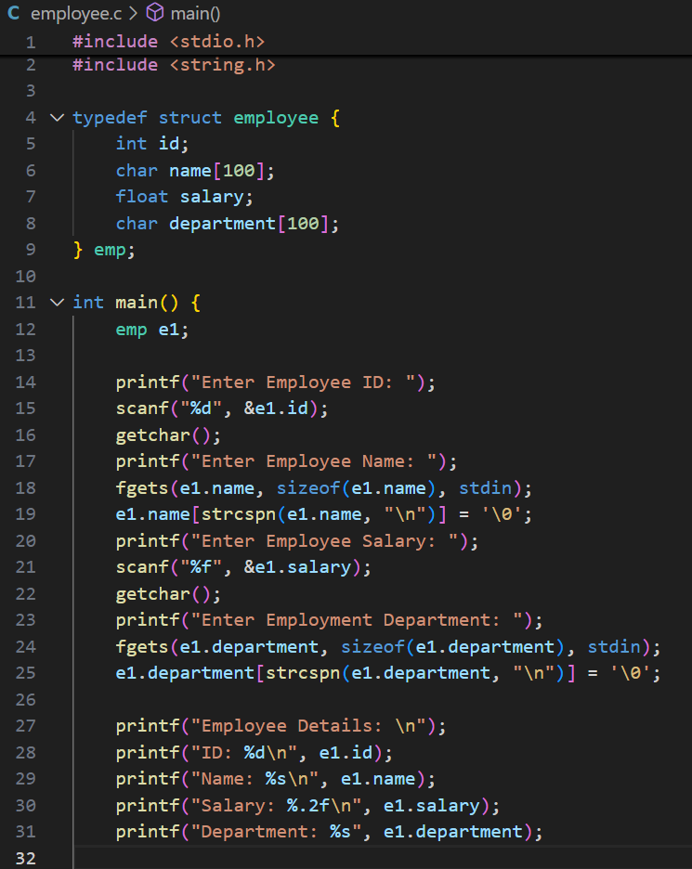

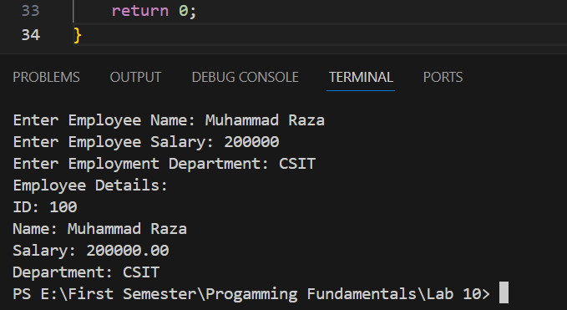

2. A phone number, such as (212) 767-8900, can be thought of as having three parts: e.g., the area

code (212), the exchange (767), and the number (8900). Write a program that uses a structure

to store these three parts of a phone number separately. Call the structure phone. Create two

structure variables of type phone. Initialize one, and have the user input a number for the other

one. Then display both numbers.

The interchange might look like this:

Enter area code: 415

Enter exchange: 555

Enter number: 1212

Then display like below:

My number is (212) 767-8900

Your number is (415) 555-1212

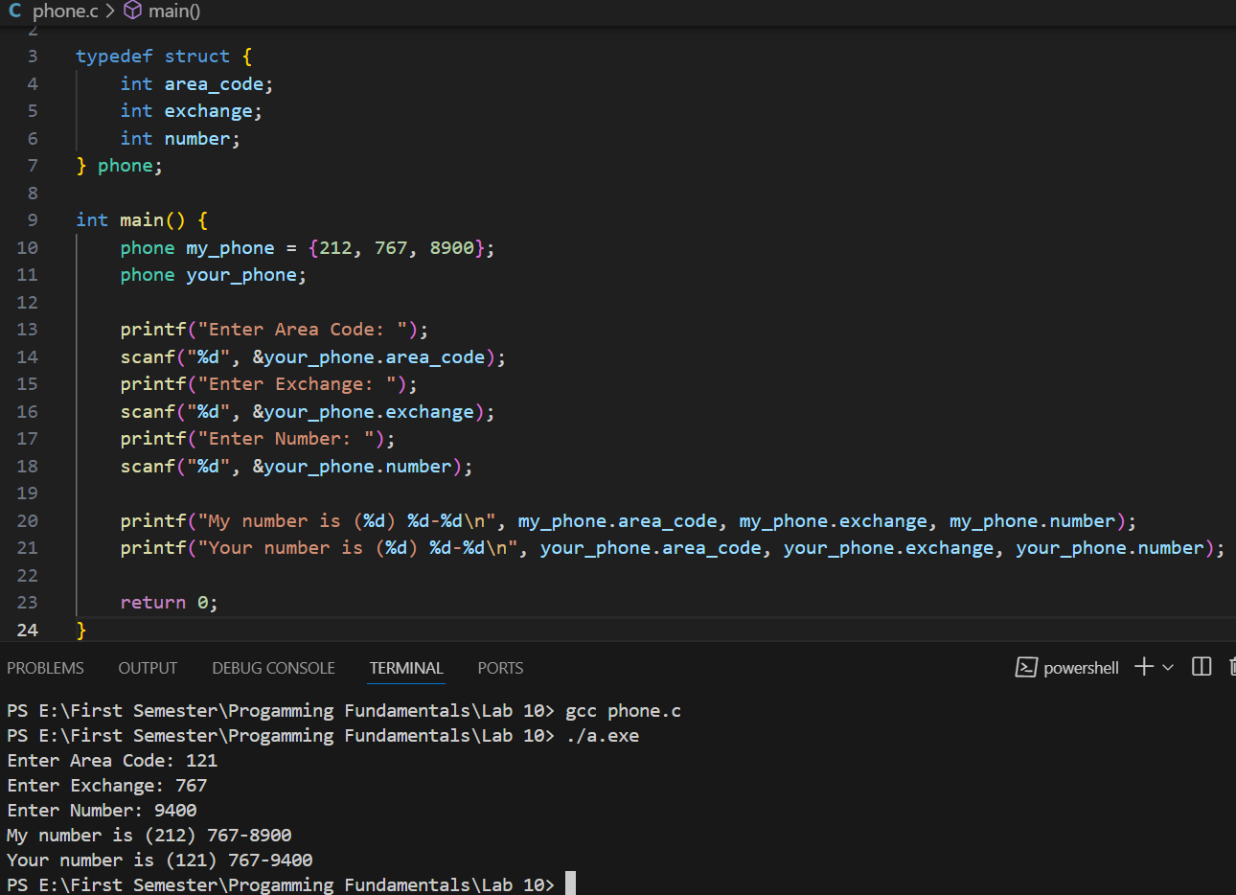

3. Write a C program that uses functions to perform the following operations:

i) Reading a complex number

ii) Writing a complex number

iii) Addition of two complex numbers

iv) Multiplication of two complex numbers

(Note: represent complex numbers using a structure.)

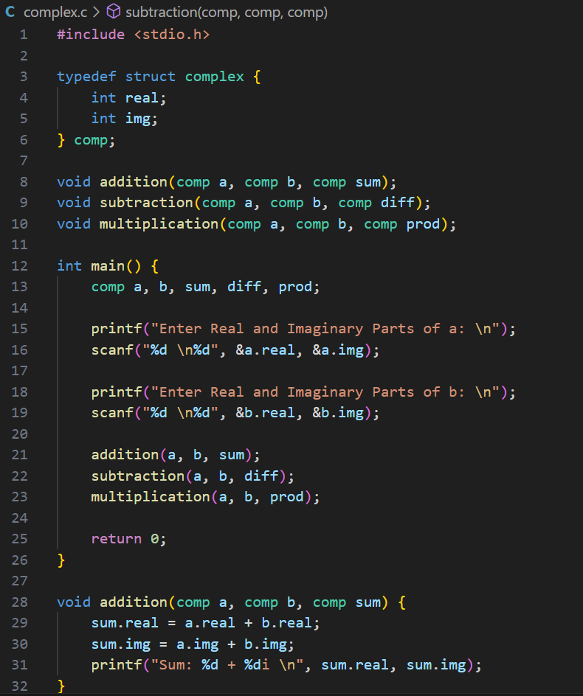

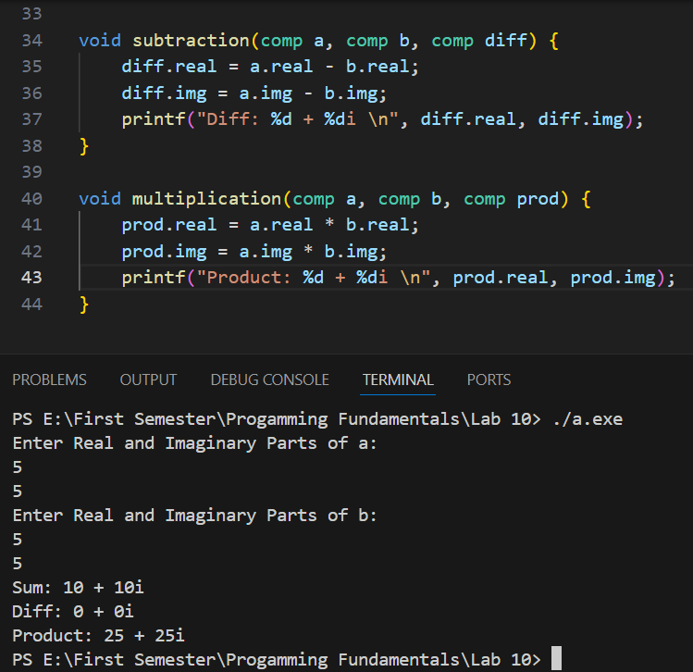

5. Define a structure to store the following student data: CGPA, courses (course name, GPA),

address (consisting of street address, city, state, zip). Input 2 student records, compare and

display which student have highest GPA in which course also Display which student has the

highest CGPA . HINT: define another structure to hold the courses and address.

